Agent for Quant Backtesting - project sheet
Problem Statement & Motivation
- LLMs can synthesize quantitative trading code from natural language, but:
  - They often mis-handle data frequency, turnover, and risk constraints.
  - Single-shot generations are brittle: small bugs can invalidate entire backtests.
- Goal: on frozen suite of strategies (to ensure fair comparison)
  - Compare an agentic, tool-using adaptive workflow against:
    - A single-shot LLM agent.
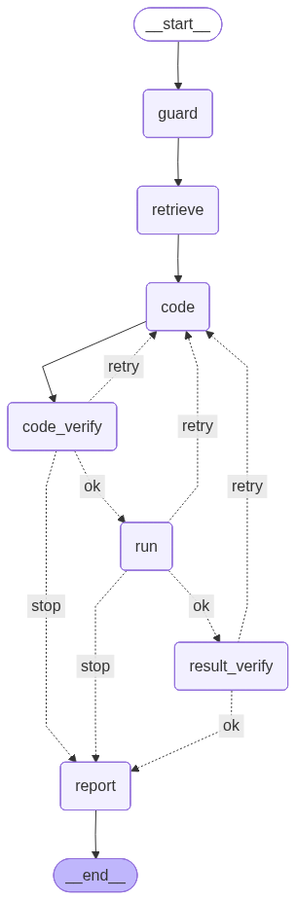
    - A pure LLM baseline that writes its own backtest script.
Agent Roles & Architecture
- SpecGuardAgent
  - Converts user prompt / JSON into validated StrategySpec.
  - Enforces task name, universe, and date bounds.
- RetrieverAgent
  - Provides tools: returns, sharpe, drawdown, compute_turnover….
- CoderAgent + CodeFixerAgent
  - Calls Argonne LLM to generate run_strategy(prices, spec) modules.
  - Prompt enforces use of tools.
  - If not first attempt, call CodeFixerAgent to analyse error for revision hints
- CodeVerifierAgent
  - Verifier: py_compile guard for syntax/import.
  - Fixer: Builds repair hints from runtime/verifier errors and re-invokes Coder.
- RunnerAgent
  - Uses DataLoader to load price panel for universe/date window, download data from API if needed.
  - Executes generated strategy, collects diagnostics.
- BTVerifierAgent
  - Checks: Finite metrics. Non-trivial performance (not all metrics ~0). Turnover ≤ 5. Sharpe within [−5, 5]…
- ReporterAgent
  - Writes success/failure reports (summary_*.md, failure_*.md).

Evaluation Setup
- Strategy suite (tasks.py): momentum_daily, momentum_weekly, pair_trading, etc.
- Comparison harness: scripts/performance_compare.py
  - For each task:
    - Agentic: 1 run (≤5 internal attempts).
    - Single-shot: 5 runs.
    - Pure LLM: 5 runs.
  - Logs: logs/performance_compare_*.log (full stdout/stderr).

Key Quantitative / Qualitative Results (current)
- Momentum_daily / Momentum_weekly
  - Agentic pipeline is reliable and consistent on these two task.
  - Single-shot agent handles these two tasks well too.
  - For example, Across runs for momentum_daily, they produce very similar metrics, e.g. ann_return ≈ 9–10%, ann_vol ≈ 14–15%, Sharpe ≈ 0.7, max_dd ≈ −37%, turnover ≈ 2.5%.
  - Pure LLM runs perform poorly:
    - Many scripts fail due to type mismatches (rolling on numpy arrays, misaligned operations).
    - When they do run, they frequently misinterpret the data structure or produce economically meaningless metrics.
- Pair_trading: Trading logic is more complex (spreads, z-scores, entry/exit thresholds), so this task stresses the systems more.
  - Agentic pipeline:
    - Typically fails on the first attempt but converges to a reasonable strategy after auto revision.
    - Example metrics: ann_return ≈ −2.3%, ann_vol ≈ 7.4%, Sharpe ≈ −0.28, max_dd ≈ −42.7%, turnover ≈ 1.6% (non-trivial and economically plausible).
  - Single-shot agent:
    - Over five runs, only about 2 produce reasonable results; others fail the non-triviality check (essentially flat or degenerate PnL).
    - When it does succeed, metrics closely match the agentic solution.
  - Pure LLM:
    - Consistently generates scripts that either crash at runtime (shape errors, missing attributes) or yield nonsensical signals/metrics.
    - Never produced a clean, verifiable pair-trading backtest in the current experiments.
Current Progress
- End-to-end agentic pipeline implemented and visualized; Comparison framework and logs in place for multiple tasks.

